**USING TV REMOTE AS A CORDLESS MOUSE FOR THE COMPUTER USING PIC MC**

**ABSTRACT**

The project is designed to use a TV remote as a cordless mouse for the computer. A conventional PC/laptop uses a mouse to operate and control all its applications. As a PC mouse is wired to the system, one has to sit near the PC to operate it. This becomes very tedious when the PC is used for presentation purposes (when using a projector). In this proposed system TV remote can be used as a cordless mouse, and the user need not operate the PC sitting near it.

A typical TV remote sends coded infrared data that is read by an IR sensor interfaced to an PIC family microcontroller. This data so received by the microcontroller sends it to the COM port of a PC through a level shifter IC. This IR code is traditionally RC5 code as followed by some manufacturers. Software named PC remote is used on the PC that recognizes data received from the microcontroller through the COM port and performs the required operation. Designated numbers on the TV remote are used to perform up - down, right - left cursor movement. Features like left click and right click of the mouse can also be performed with of the TV remote.

Further this project can be enhanced using Bluetooth/ RF technology to overcome the traditional line of sight communication drawbacks of the infrared type.

**BLOCK DIAGRAM**

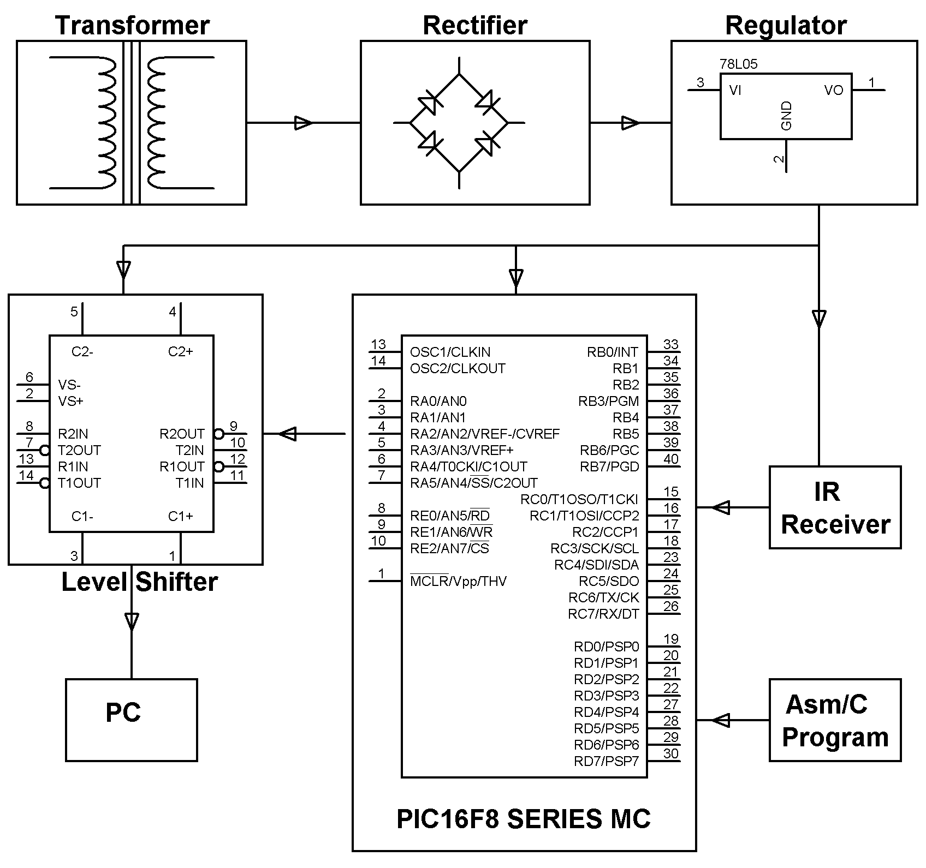

**SOFTWARE REQUIREMENTS:**

MPLAB & CCS C compiler

Languages: Embedded C or Assembly

**HARDWARE REQUIREMENTS:**

PIC16F8 series Microcontroller, T.V Remote, TSOP, Level Shifter, Resistors, LED, Capacitors, Diodes, Transformer, Crystal, Voltage Regulator.